**ACO Task:-**

1. time Kevin prints a script, it prints out two pages with a blank second page. Please combine the 2 sentences circled in the picture attaced, and decrease the font slightly . hopefully that will fix that issue.

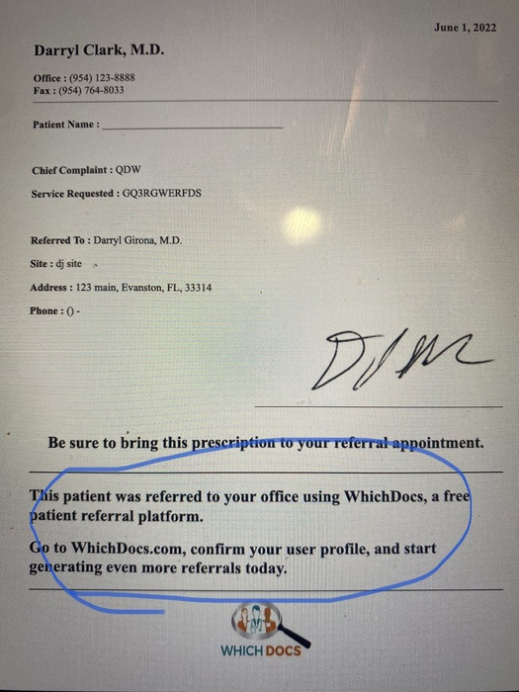

while you're add it....  Above the circled text mentioned above, please add

"Dear Dr. ______"

with the blank being filled by the referred to Provider's last name.

**Front-end time --- 1 Hours**

**Back-end time-- 0 Hour**

**Done from Front-end site and uploaded**

1. FDU signup screen  needs to also mention you need at least 1 number. currently says

"Password must be at least 8 Chars, One Upper & Lower Case and One special character"

**Front-end time --- 0.5 Hours**

**Back-end time-- 0 Hour**

**Done from Front-end site and uploaded**

1. When a provider **adds a new insurance**, it does add it to the list as "to be verified" but we don't know it is there. Can you please program it to send an email to info@whichdocs, title new insurance to be verified, and if possible , the name of the insurance and the provider that requested it.

**1st part**

**Front-end time --- 0 Hours**

**Back-end time-- 5 Hours**

Secondly, is it possible for providers to suggest **multiple** new insurances in their profile page, separated by commas,  so they don't have to do them one at a time?

**2nd part**

**Front-end time --- 4 Hours**

**Back-end time-- 8 Hours**

**Done from Front-end site and uploaded**

1. Superadmin / Affiliations. Within an individual affiliation (ex:   
   Broward County Medical Association) "Export Provider list" doesn't seem to download anything

**Front-end time --- 2 Hours**

**Back-end time-- 5 Hours**

**Done from Front-end site and uploaded**

1. Superadmin / Providers.  if you search providers with a screen for Broward County Medical Association affiliation, there are 573 results and oddly does not include Kevin Shrock. If you go to Superadmin / Affiliations and look at the list, there are 579 AND Kevin in included.

**Front-end time --- 2 Hours**

**Back-end time-- 5 Hours**

1. **Unregistered** Providers can currently reset a password even if they are not yet registered, as long as we already have their email in our database. That is not right.

IF a provider's Email address is in our database AND they are registered, they should receive the PW reset email.

otherwise,

IF EITHER

[a provider's Email address is in our database AND they are NOT yet registered]

OR

[their email address is NOT in our database],

they should see a message "That email is not yet registered. Please go back to whichdocs.com and click Signup"

**Front-end time --- 0.5 Hours**

**Back-end time-- 5 Hours**

**Total Front-end time --- 10 Hours**

**Total Back-end time-- 28 Hours**